LAB EXPERIMENT 4
ONLINE TRAIN RESERVATION SYSTEM

AIM
To design and implement a simple Online Train Reservation System using HTML, CSS, and JavaScript. The system allows users to search trains by route and journey date, view sample seat availability and classes, enter passenger details, book tickets, view a generated PNR, check PNR status, and cancel a reservation.

PROCEDURE
- Create a project folder named OnlineTrainReservation.
- Create an HTML file named index.html using Notepad or a code editor.
- Design the train search form with source station, destination station, journey date, and class selection.
- Use CSS to format the webpage, input fields, buttons, and result panels.
- Use JavaScript to validate search details and display sample train information and seat availability.
- Create a reservation form to collect passenger name and selected travel class.
- When the user books a ticket, generate a demonstration PNR number and show the booking details.
- Provide a PNR-status search and a cancellation feature for the most recent booking.
- Save the file and open it in a web browser.
- Test train search, booking, PNR status, and ticket cancellation. Capture screenshots of the output.

CODE
Save the following complete code as index.html.
<!DOCTYPE html>
<html lang="en">
<head>
<meta charset="UTF-8">
<meta name="viewport" content="width=device-width, initial-scale=1.0">
<title>Online Train Reservation System</title>
<style>
body { font-family: Arial, sans-serif; margin: 0; background: #f1f4f8; color: #202938; }
header { background: #123c69; color: white; text-align: center; padding: 20px; }
.container { max-width: 800px; margin: 25px auto; padding: 22px; background: white;
border-radius: 10px; box-shadow: 0 3px 10px #0002; }
h2 { color: #123c69; }
label { display: block; margin-top: 12px; font-weight: bold; }
input, select { width: 100%; box-sizing: border-box; padding: 10px; margin-top: 5px; }
button { padding: 11px 15px; margin-top: 14px; background: #123c69; color: white;
border: 0; border-radius: 5px; cursor: pointer; }
button:hover { opacity: .9; }
.cancel { background: #b3261e; }
.card { margin-top: 14px; padding: 14px; background: #eaf3ff; border-radius: 7px; }
.note { font-size: 13px; color: #555; }
footer { text-align: center; padding: 16px; }
</style>
</head>
<body>
<header>
<h1>Online Train Reservation System</h1>
<p>Search Trains | Reserve Tickets | Check PNR</p>
</header>

<div class="container">
<h2>1. Search Trains</h2>
<label>Origin Station</label>
<input id="origin" placeholder="e.g. Chennai">
<label>Destination Station</label>
<input id="destination" placeholder="e.g. Bengaluru">
<label>Journey Date</label>
<input id="journeyDate" type="date">
<label>Travel Class</label>
<select id="travelClass">
<option value="Sleeper">Sleeper (SL)</option>
<option value="AC 3 Tier">AC 3 Tier (3A)</option>
<option value="AC 2 Tier">AC 2 Tier (2A)</option>
<option value="AC Chair Car">AC Chair Car (CC)</option>
</select>
<button onclick="searchTrains()">Search Trains</button>
<div id="trainResults"></div>

<hr>
<h2>2. Reserve a Ticket</h2>
<label>Passenger Name</label>
<input id="passengerName" placeholder="Enter passenger full name">
<label>Age</label>
<input id="passengerAge" type="number" min="1" max="120" placeholder="Enter age">
<button onclick="bookTicket()">Book Ticket</button>
<div id="bookingMessage"></div>

<hr>
<h2>3. Check PNR Status</h2>
<label>PNR Number</label>
<input id="pnrInput" placeholder="Enter your PNR number">
<button onclick="checkPNR()">Check PNR</button>
<div id="pnrResult"></div>

<hr>
<h2>4. Cancel Reservation</h2>
<label>PNR Number to Cancel</label>
<input id="cancelPNR" placeholder="Enter PNR number">
<button class="cancel" onclick="cancelTicket()">Cancel Ticket</button>
<div id="cancelMessage"></div>

<hr>
<h2>5. Booking History</h2>
<ul id="bookingHistory"><li>No reservations yet.</li></ul>
<p class="note">Lab demo only: train details, fares, availability, and PNR statuses are simulated.
This page does not connect to a railway database or payment gateway.</p>
</div>

<footer>Online Train Reservation System | Lab Experiment</footer>

<script>
const reservations = [];

function searchTrains() {
const origin = document.getElementById("origin").value.trim();
const destination = document.getElementById("destination").value.trim();
const date = document.getElementById("journeyDate").value;
const travelClass = document.getElementById("travelClass").value;

if (!origin || !destination || !date) {
alert("Please enter origin, destination, and journey date.");
return;
}
if (origin.toLowerCase() === destination.toLowerCase()) {
alert("Origin and destination must be different.");
return;
}

document.getElementById("trainResults").innerHTML = `
<div class="card">
<h3>Sample Train Available</h3>
<p><b>Train:</b> Southern Express (Demo)</p>
<p><b>Route:</b> ${escapeHTML(origin)} to ${escapeHTML(destination)}</p>
<p><b>Date:</b> ${date}</p>
<p><b>Class:</b> ${travelClass}</p>
<p><b>Sample availability:</b> Available</p>
<p><b>Sample fare:</b> ₹850</p>
</div>`;
}

function bookTicket() {
const name = document.getElementById("passengerName").value.trim();
const age = Number(document.getElementById("passengerAge").value);
const origin = document.getElementById("origin").value.trim();
const destination = document.getElementById("destination").value.trim();
const date = document.getElementById("journeyDate").value;
const travelClass = document.getElementById("travelClass").value;

if (!origin || !destination || !date) {
alert("Search trains first by entering the journey details.");
return;
}
if (!name || !Number.isInteger(age) || age < 1 || age > 120) {
alert("Please enter a valid passenger name and age.");
return;
}

const pnr = String(Math.floor(1000000000 + Math.random() * 9000000000));
const reservation = {
pnr, name, age, origin, destination, date, travelClass,
status: "Confirmed", fare: 850
};
reservations.push(reservation);

document.getElementById("bookingMessage").innerHTML = `
<div class="card">
<h3>Reservation Successful (Demo)</h3>
<p><b>Passenger:</b> ${escapeHTML(name)}</p>
<p><b>Train:</b> Southern Express (Demo)</p>
<p><b>Route:</b> ${escapeHTML(origin)} to ${escapeHTML(destination)}</p>
<p><b>Class:</b> ${travelClass}</p>
<p><b>Fare:</b> ₹850 (sample)</p>
<p><b>PNR:</b> ${pnr}</p>
<p><b>Status:</b> Confirmed (simulated)</p>
<button onclick="window.print()">Print Page / Ticket</button>
</div>`;
updateHistory();
}

function checkPNR() {
const pnr = document.getElementById("pnrInput").value.trim();
const reservation = reservations.find(r => r.pnr === pnr);
const result = document.getElementById("pnrResult");

if (!pnr) {
alert("Please enter a PNR number.");
return;
}
if (!reservation) {
result.innerHTML = '<div class="card">PNR not found in this demo session.</div>';
return;
}
result.innerHTML = `<div class="card">
<b>PNR:</b> ${reservation.pnr}<br>
<b>Passenger:</b> ${escapeHTML(reservation.name)}<br>
<b>Journey:</b> ${escapeHTML(reservation.origin)} to ${escapeHTML(reservation.destination)}<br>
<b>Date:</b> ${reservation.date}<br>
<b>Status:</b> ${reservation.status}
</div>`;
}

function cancelTicket() {
const pnr = document.getElementById("cancelPNR").value.trim();
const reservation = reservations.find(r => r.pnr === pnr);
const result = document.getElementById("cancelMessage");

if (!pnr) {
alert("Please enter a PNR number.");
return;
}
if (!reservation) {
result.innerHTML = '<div class="card">PNR not found in this demo session.</div>';
return;
}
if (reservation.status === "Cancelled") {
result.innerHTML = '<div class="card">This ticket is already cancelled.</div>';
return;
}

reservation.status = "Cancelled";
const refund = reservation.fare * 0.8;
result.innerHTML = `<div class="card">
<h3>Ticket Cancelled (Demo)</h3>
<p>PNR: ${reservation.pnr}</p>
<p>Sample refund estimate: ₹${refund.toFixed(2)} (80% of sample fare)</p>
<p class="note">Actual railway cancellation charges and refunds depend on the applicable rules.</p>
</div>`;
updateHistory();
}

function updateHistory() {
const list = document.getElementById("bookingHistory");
list.innerHTML = "";
if (reservations.length === 0) {
list.innerHTML = "<li>No reservations yet.</li>";
return;
}
reservations.forEach(r => {
const li = document.createElement("li");
li.textContent = `${r.name} | ${r.origin} to ${r.destination} | PNR: ${r.pnr} | ${r.status}`;
list.appendChild(li);
});
}

function escapeHTML(value) {
return value.replace(/[&<>"']/g, char => ({
"&": "&amp;", "<": "&lt;", ">": "&gt;", '"': "&quot;", "'": "&#39;"
}[char]));
}
</script>
</body>
</html>

IMPLEMENTATION
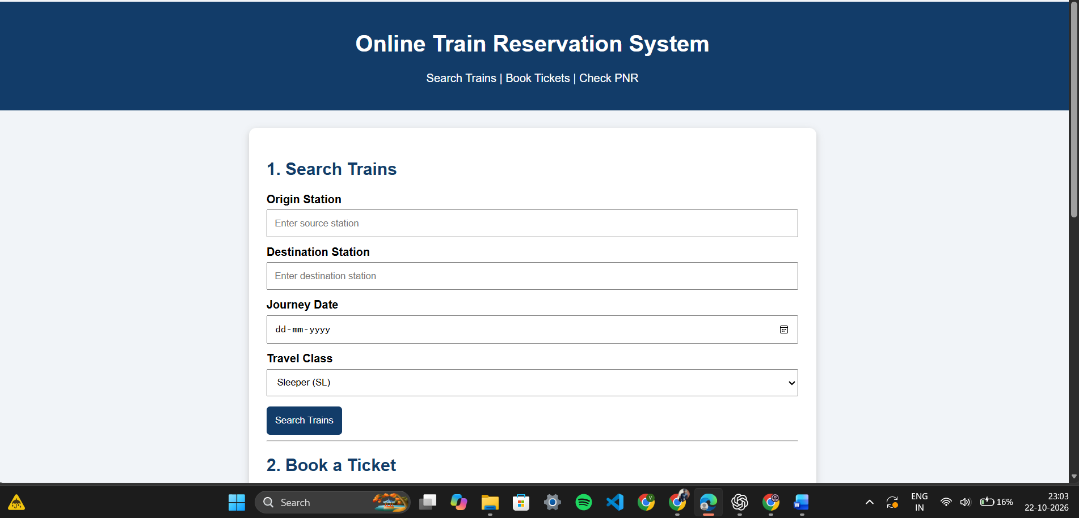
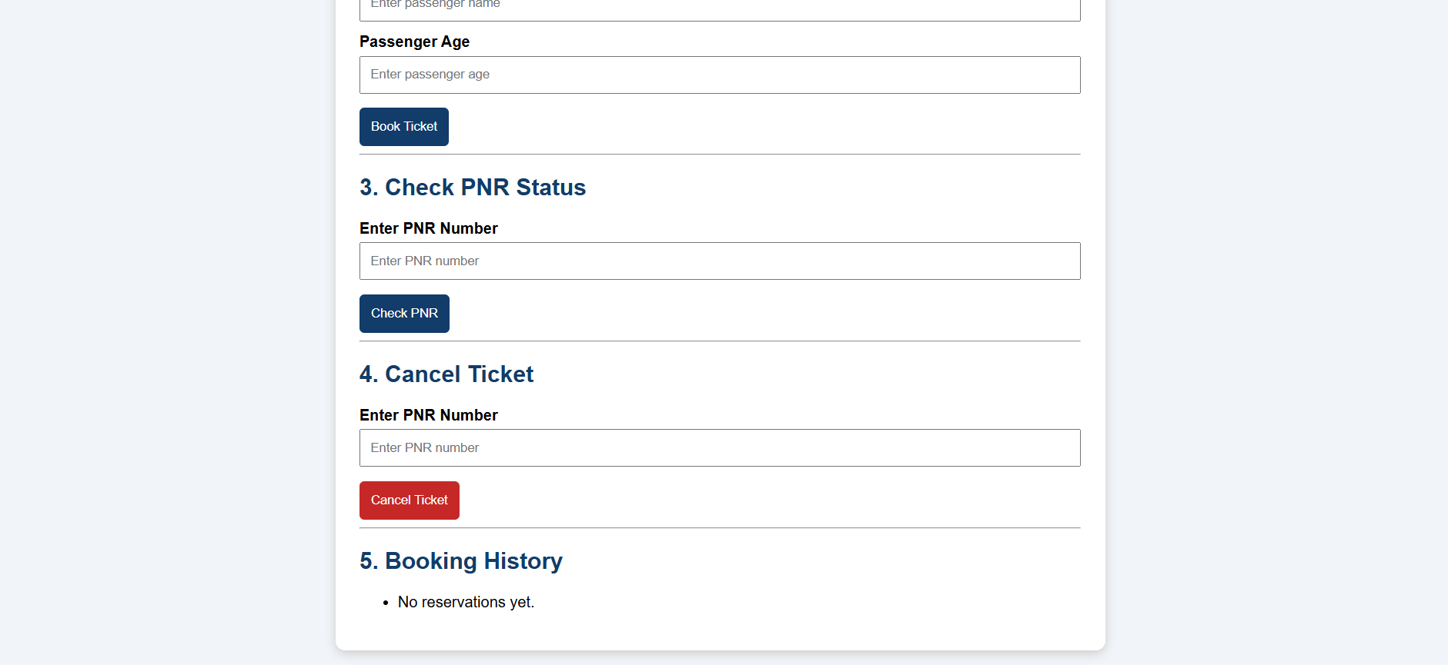

RESULT
The Online Train Reservation System front-end prototype was implemented successfully. It demonstrates train searching, class selection, passenger entry, ticket booking, PNR generation, PNR status checking, cancellation, a sample refund calculation, booking history, and ticket printing. Real-time train information, secure payment, user accounts, email notifications, and persistent storage require a backend, database, and authorized integrations.

